Decreases in global CO2 emissions due to COVID-19 pandemic

Zhu Liu et al.
Department of Earth System Science, Tsinghua University
Contact: zhuliu@tsinghua.edu.cn

Abstract
Assessing the impacts of COVID-19 are of paramount importance for global sustainability. Using a coordinated set of high-resolution sectoral assessment tools, we report a decrease of 4.2% in global CO₂ emission in first quarter of 2020. Our emission estimates reflect near real time inventories of emissions from power generation, transportation, industry, international aviation and maritime sectors in 34 countries that account for >70% of world energy-related CO2 emissions in recent years. Regional variations in CO₂ emissions are significant, with a decrease in China (-9.3%), US (-3.0%), Europe (EU-27 & UK) (-3.3%) and India (-2.4%), respectively. The decline of short-lived gaseous pollutants, such as NO₂ concentration observed by Satellites (-25.73% for China, -4.76% for US) and ground observations (-23% for China) is consistent with the estimates based on energy activity (-23.94% for China, -3.52% for US), but the decline is not seen in satellite assessments of aerosol optical depth (AOD) or dry column CO₂ (XCO₂). With fast recovery and partial re-opening of national economies, our findings suggest that total annual emissions may drop far less than previously estimated (e.g., by 25% for China¹ and more than 5% for the whole world²). However, the longer-term effects on CO2 emissions are unknown and should be carefully monitored using multiple measures.

Introduction
COVID-19 had decimated economies worldwide, with some countries experience substantial reduction of industrial activities and associated energy consumption from 3~4 % to over 30% in just weeks^{3,4}. Initial estimates based on selected power plants and the satellite observation suggested^{1,2} that related decreases in global CO2 emissions could be the largest since the end of the Second World War. However, thorough quantitative analyses of the pandemic’s effects on energy use and emissions are lacking⁵. This is largely because published datasets of greenhouse gas emissions are based on annual statistics which commonly lag behind by one or more years⁶⁻¹¹. A high temporal resolution emission dataset is critical to capture the immediate effects of an event like the COVID-19 pandemic. Such improved temporal resolution might also allow policy makers to more quickly observe the effects of policies aimed at decreasing CO₂ emissions, facilitating rapid adjustments.
Here, we present a near real time global emission dataset of monthly and weekly energy consumption and associated CO2 emissions, We use this dataset to estimate the impact on CO2 emission trends due to COVID-19. The dataset was compiled from monthly and weekly energy statistics and industrial products by sectors at the global scale, cross-checking and comparing the estimates with independent measurements of CO2 and air quality from satellites and ground observations. We show that the higher resolution emission dataset provides an accurate the impact of COVID-19 and the follow up impacts from the economic shock it created. We further highlight remaining uncertainties in the emissions estimates.

Emission estimated by inventories
The global CO2 emissions through the first quarter of 2020 is calculated by the monthly, weekly, daily and hourly energy consumption statistics and proxy industrial products data of individual sectors (See methods and SI Data Table 1 for data sources). Globally, emissions from 34 countries including China, US, UK, 27 Europe countries (EU27: Austria, Belgium, Bulgaria, Croatia, Republic of Cyprus, Czech Republic, Denmark, Estonia, Finland, France, Germany, Greece, Hungary, Ireland, Italy, Latvia, Lithuania, Luxembourg, Malta, Netherlands, Poland, Portugal, Romania, Slovakia, Slovenia, Spain and Sweden), Russia, Japan, Brazil and India are calculated as well as those for international aviation and maritime emissions. Together, these as estimated to contribute 70% of the global total emissions in 2019.
We estimate a 3.8% decrease in cumulative CO₂ emission from these countries in the first quarter of 2020 compared with same period of 2019, with another 0.4% decrease of global total emission from international aviation and maritime emissions (Table 1). Declines in China (-9.3%), US (-3.0%), Europe (EU27 & UK) (-3.3%) and India (-2.4%) dominate the change. For the perspective of sectoral emissions, the decline of global CO₂ emissions is contributed by transport sector (-6.0%, -121.7 MtCO₂), power sector (-3.3%, -111.2 MtCO2) and industry sector (-4.9%, -78.1 MtCO₂). Total emission reduction in first quarter comparing with the last year reached -310.9 MtCO₂, which is still smaller than the annual emission decline around the economic crisis of 2008. China as the country with early pandemic had the largest emission reduction of -217.0 MtCO₂, followed by US (-41.2 MtCO₂), Europe (EU27 & UK) (-26.2 MtCO₂) and India (-13.9 MtCO₂).

Table 1. Emission decline and changes by countries/regions in the first quarter in 2020. (See SI Table 1 for full sectoral changes by countries/regions)
Unit: MtCO2 | Sectoral Changes |  |  | Summary | Growth Rates (%)
Unit: MtCO2 | Power | Transport | Industrial | Summary | Growth Rates (%)
China | -75.7 | -83.1 | -58.1 | -217.0 | -9.3%
India | 2.9 | -6.1 | -10.7 | -13.9 | -2.4%
US | -21.7 | -11.7 | -2.3 | -35.8 | -3.0%
EU | -7.0 | -16.2 | -3.0 | -26.2 | -3.3%
Russia | -4.4 | 0.0 | 1.1 | -3.3 | -0.8%
Japan | -5.1 | -1.0 | -4.5 | -10.6 | -3.8%
Brazil | -0.2 | -3.5 | -0.5 | -4.2 | -3.9%
Summary | -111.2 | -121.7 | -78.1 | -310.9 | -3.8%
International aviation | - | - | - | -19.8 | -8.0%
International shipping | - | - | - | -35.5 | -13.3%
World | - | - | - | -366.2 | -4.2%

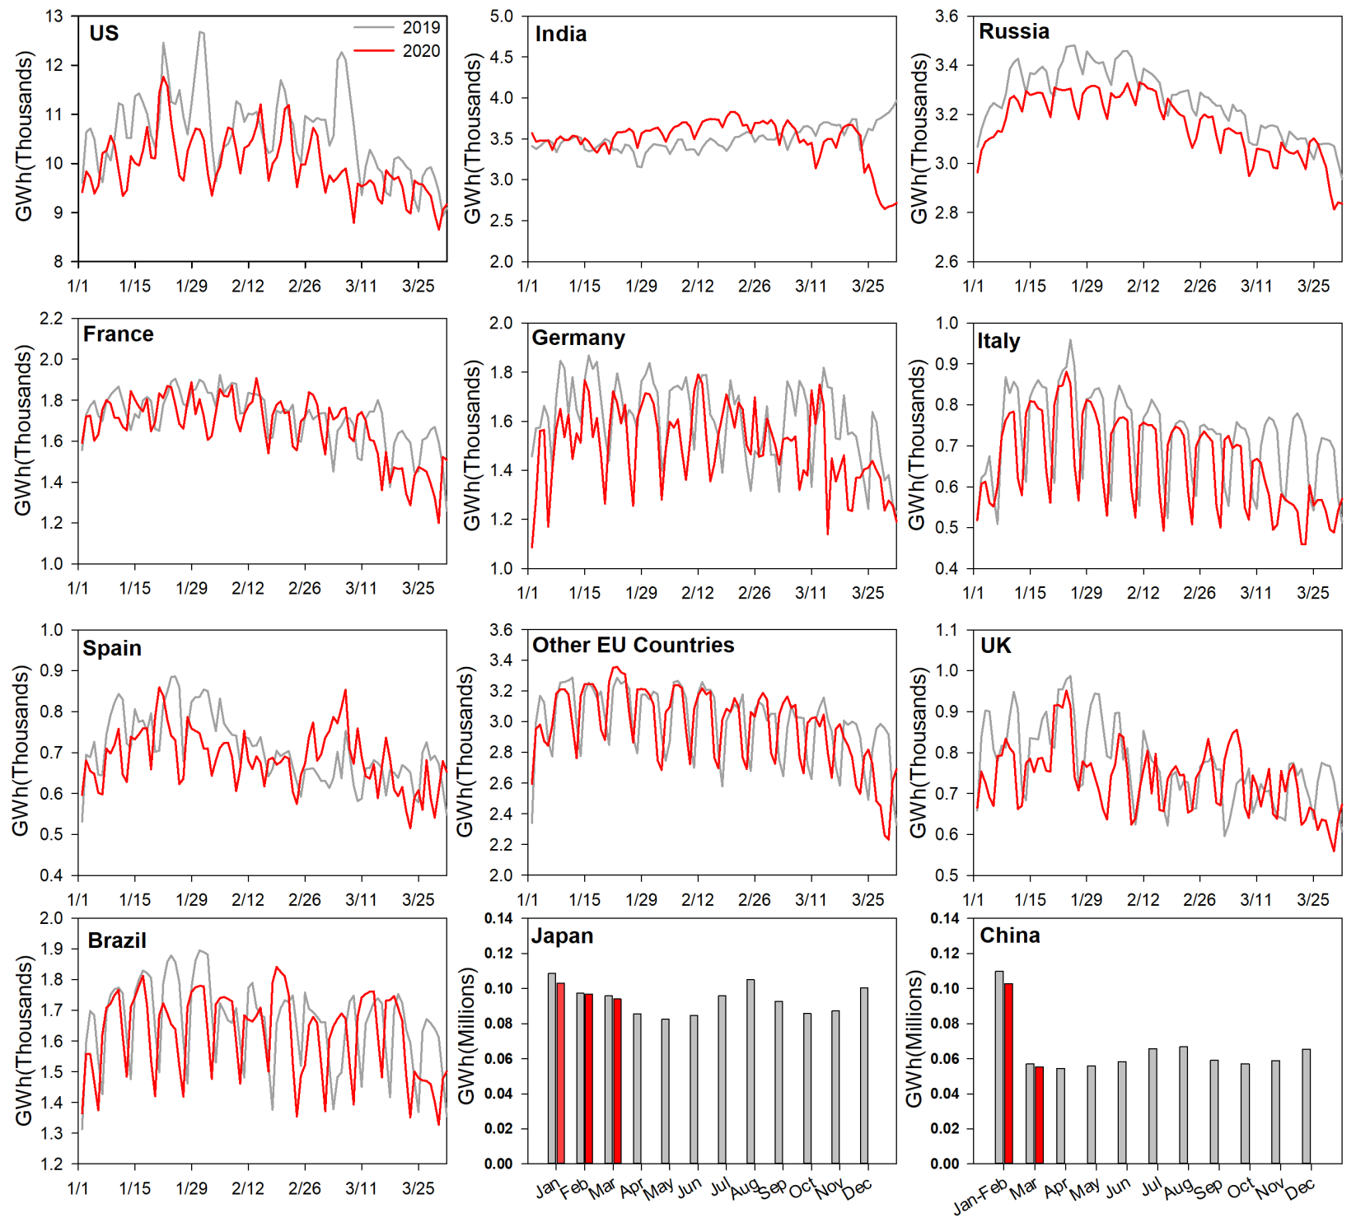
Fig 1. Daily/monthly electricity generation in 2020 in US, India, Russia, France, Germany, Italy, Spain, other EU countries (Austria, Belgium, Bulgaria, Czech Republic, Denmark, Estonia, Finland, Greece, Hungary, Latvia, Lithuania, Netherlands, Poland, Portugal, Romania, Slovakia, Slovenia, and Sweden), UK, Brazil, Japan and China. (See SI Table 2)

Power generation (See Methods for data and calculation process) is the key consumer for global fossil fuel consumption (account 40% of global fossil emission), especially for coal. The emission decrease in the power sector was estimated directly by near real time electricity production data combined with information on the carbon content of the electricity mix from hourly to monthly time scale, depending upon countries, compiled from publications of governments, electricity producer associations and companies (See Methods). The largest decline in total (and percentage) of these emissions is in China (Figure 1). The official reported data show the -8.2% reduction of electricity generation in China in January and February together, and -4.6% reduction in March, compared with the same period last year. The decrease of electricity generation is more obvious in March in other regions consistent with the timing of the pandemic of COVID-19. In US the electricity generation decreased with -6.7% in March, and France, Germany, UK and Italy decreased by -4.7%, -8.2%, -0.9% and -14.5% respectively. There is also sharp decrease in India (-8.7%) in March. In the first quarter, global CO₂ emissions in power sector have declined by -3.3% (-111.2 MtCO₂), as a result of declines in China (-6.8%, -75.7 MtCO₂), in the US 4.9% (-4.9%, -21.7 MtCO₂) and in EU-27 & UK (-2.5%, -7.0 MtCO₂) in Europe (EU-27 & UK). Generation in India was largely unchanged in March (-1.0%, -2.9 MtCO2) (See SI Data table 2.1 and 2.2).

Fig 2. Monthly emission changes in transport sector in February, March and the first quarter of 2020. (See SI Table 3)
Transport sector (See Methods for data and calculation process) contributes the second largest share (25%) of the world total emissions but contributes most in the decline of total emission (6.0%, 121.7 MtCO₂) in first quarter in 2020 (Figure 2). Emissions from transport sector are calculated based on the mobility collected from Google Mobility Reports and Baidu Migration Scale Index during the period (See Methods and SI Data Table 3.1-3.3). In China, even though cities started locking down since the last week in January, the emissions from transport have still increased by +2.6% due to an earlier start of the Spring Festival travel rush in 2020 when comparing with same period last year. However, since February, the emissions from transport have dropped significantly, by -75.1% in February and -34.2% in March. In the first quarter of 2020, the emissions from transport have dropped -37.2% (-83.1 MtCO₂) in China. Since the pandemic has spread worldwide in March, the emission from transport have dramatically decreased in other countries. Emissions in US and India have dropped by -10% and -22.9% in March. Emissions in European countries have fell by an average of -22.8% in March, while Italy and Spain have decreased most by -51.5% and -40.8% respectively. In the first quarter of 2020, emissions in US, India and Europe (EU27 &UK) have dropped -2.7% (-11.7 MtCO₂), -7.6% (-6.1 MtCO₂), -7.3% (-16.2 MtCO₂) respectively.
Fig 3. Monthly emission changes in industrial sector by countries/countries. (See SI Table 4)

Emissions from manufacturing, processing, chemical industry and other industrial activities are calculated together as Industrial Sector that contributes 24% of the total CO₂ emissions, but its shares are much larger in developing countries, i.e., 29.8% in China and 26.1% in India. Thus, separated data on steel industry, cement industry, chemical industry and other industry are collected for China and India for more accurate estimation (SI Data Table 4.1-4.5). Here we considered industrial emissions from fuel consumption and process emissions, while electricity related emissions for the industry are counted in the power sector. In the first quarter of 2020, the industrial emissions have declined by -7.0%, -2.2%, -3.2% respectively in India, US and EU, with the largest decline in March by -22.6%, -5.5%, and -6.4% respectively (Figure 3, SI Data Table 4.1-4.5). In China, the largest decline occurred in the first two months in 2020 by 9-.8%, and have fell by -8.1% in the first quarter of 2020. The emissions from steel industry are 41.6% of the total industrial emissions in China. Compared to the same periods of last year, the emissions from steel industry in China have increased +1.4% and +5.0% in January and February but dropped -1.7% in March. Despite the pandemic, the emissions from steel industry were 1.4% larger in the first quarter of 2020 than in 2019. For the cement industry, China official reports show declines of -29.5% in January and February together and -18.3% in March. For the first quarter in 2020, the emissions from cement industry in China has dropped -23.9% compared with 2019. Emissions from chemical industry in China have also decreased by -4.2%. For other industry in China, the emissions have fell by -13.6%.
Emissions from steel industry in India also accounts for over 47% of the total industrial emissions, and the emissions have decreased by -13.9% (-3.9 MtCO₂) in March and -5.3% (-4.5 MtCO₂) in the first quarter in 2020. Emissions from cement industry in India have dropped -10.2% in the first quarter. In the first quarter of 2020, the global emissions from industrial sector have fell by -4.9%, with the contribution by China (-8.1%, -58.1 MtCO₂), US (-2.2%, -2.3 MtCO₂), EU & UK (-3.2%, -3.0 MtCO₂) and India (-7.0%, -10.7 MtCO₂).
The number of flights decreased significantly in February and March (Figure S1). Our results about weekly emissions from international aviation (See Methods for data and calculation process) show that international aviation emissions have increased +0.8% (+0.7 MtCO₂) in January and dropped -8.6% (-6.9 MtCO₂) and -15.2% (-13.6 MtCO₂) in February and March respectively. The international aviation emissions have decreased by -8.0% (-19.8 MtCO₂) in total in the first quarter of 2020. In China, the international aviation emissions in February and March have significantly dropped by -55.2% (-3.2 MtCO₂) and -40.1% (-2.4 MtCO₂) respectively. Elsewhere, the decline has been particularly significant in March. In March, the international aviation emissions in US have decreased by -2.2% (-0.3 MtCO₂), the emissions in Europe such as in UK and Italy have dropped by -23.7% (-1.3 MtCO₂) and -49.3% (-0.9 MtCO₂) respectively, and the emissions in Asia such as in Japan and South Korea have declined by -16.8% (-0.5 MtCO₂) and -49.7% (-1.1 MtCO₂) respectively. However, the emissions in India in the first quarter in 2020 are larger than the same period last year.

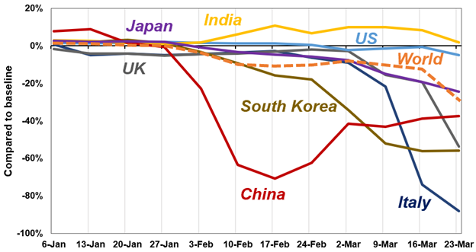

Figure S1 Change in numbers of the flights
Global shipping CO₂ emissions (See Methods for data and calculation process) have decreased by -13.3% (-35.4 Mt CO₂) in the first quarter of 2020 compared to the same period in 2019. Emissions from container ships and bulk carries ships decreased by -15% (-9.2 Mt CO₂) and -25.8% (-13.1 Mt CO₂), respectively. Emissions from oil tankers ships increased by +2.2% (+0.8 Mt CO₂) due to the decline in international oil prices. Emissions from other 19 ship classes were reduced by -11.5% (-13.9 Mt CO₂).
The observation of air quality and dry column CO₂ (XCO₂)
It is obvious that the strong reduction of fuel use must have resulted into a drop of nitrogen oxides and aerosols concentrations which have a short-life time in the atmosphere. The situation is a bit more complex for CO2 because natural fluxes from the vegetation and soils can be equal in magnitude in a given month to those of fossil fuel and cement emissions, the sign being different between the non-growing season when soil respiration add CO2 to the atmosphere and amplify emissions, whereas in the growing season, photosynthesis CO2 uptake removes CO2 and offset emissions.
The results of tropospheric nitrogen dioxide (NO₂) column concentration data from satellite observation and surface air quality data by ground monitoring sites have exhibited a similar decreasing trend with global CO₂ emissions. We collected NO₂, aerosol optical depth (AOD) and column-averaged dry air mole fraction of CO2 (XCO₂) data from satellites (NO₂ from OMI, AOD from MODIS and XCO2 from GOSAT) and the global surface daily average nitrogen dioxide (NO₂, μg/m³), carbon monoxide (CO, μg/m³), and air quality data in China and US to investigate the plausible impact of COVID-19 on air quality and atmospheric CO₂.
Fig 4. Tropospheric column NO₂ Observation in the first quarter of 2020.

Surface air quality data in China is collected from the daily report by Ministry of Ecology and Environment of China (http://www.mee.gov.cn/). Measurements of daily average nitrogen dioxide (NO₂, μg/m³), carbon monoxide (CO, μg/m³), and particulate matter smaller than 2.5 μm (PM_{2.5}, μg/m³) from 1580 sites are used to estimate pollution changes between the first quarters of 2019 and 2020. Surface air quality data in U.S. is downloaded from the Air Quality System (AQS) operated by the U.S. Environmental Protection Agency (https://www.epa.gov/aqs). Measurements of daily maximum 1-hour NO₂ (ppb), daily maximum 8-hour CO (ppm), and daily average PM_{2.5} (μg/m³) from 983 sites are used. For March 2020, data availability is limited in U.S. with 20 sites for NO₂, 31 for CO, and 309 for PM_{2.5}. Sites with missing data for NO₂/CO (PM_{2.5}) at over 20 (5) days in any months will be excluded.
Table 2 shows the NO2 decrease in 2020 compared to 2019 over each country in each month. In China, January, February, and March 2020 decreased by -32.27%, -34.22%, -4.53% respectively compared to 2019. Overall, NO₂ decreased by -23.67% in the first quarter of 2020 compared to 2019. We notice that a rapid drop appeared in February 2020 for China (Figure 5d), which is greater than two sigma ($σ=45.053×{10}^{3}molec {km}^{-2}$), and NO₂ decrease remained in February and March Such a significant NO₂ drop rarely appeared in the previous years except for Jan 2018. However, the decrease in Jan 2018 did not last more than a month, indicating the continuous decrease of NO₂ from Jan – March in China were associated with COVID-19. In US, the decrease of NO₂ at first appeared in Feb and stayed decreasing in March 2020 (Figure 5d). Compared to the same time in 2019, NO₂ decreased by -23.08% and -14.32% in February and March 2020, respectively (Table 2). EU4 (UK, France, Germany, and Italy) holds the similar changes as the USA for NO₂. The US and EU4 statistics in NO₂ seem to reflect ~ one-month delay of COVID-19 outbreak in the western countries. India had weaker decline in NO₂ than other regions. The epidemic situation in India even lags behind US and EU4. No cases have been reported in India until March 2 and there were only 1,834 cases until April 1. Thus, the drastic decrease of NO₂ in the first quarter of 2020 is very likely associated with transportation and industry shutdown due to COVID-19, with NOx emissions primarily contributed by diesel engines of transportation and coal combustion from power generation.
Table 2 Changes of 2020 compared to 2019
 |  | China | US | EU4 | India
OMI  NO2 | January | -32.26% ± 12.03% | 22.98% ± 16.02% | 15.78% ± 15.24% | -8.96% ± 13.63%
OMI  NO2 | February | -34.22% ± 11.87% | -23.08% ± 12.63% | -25.12% ± 12.40% | -13.79% ± 13.36%
OMI  NO2 | March | -4.53% ± 13.77% | -14.32% ± 13.24% | -15.56% ± 13.22% | -13.37% ± 13.29%
OMI  NO2 | January-March | -25.73% ± 12.51% | -4.76% ± 13.75% | -9.71% ± 13.54% | -11.99% ± 13.47%
MODIS  AOD | January | 10.17% ± 49.22% | 10.64% ± 95.67% | 19.81% ± 77.76% | -5.46% ± 36.27%
MODIS  AOD | February | -7.88% ± 41.08% | -3.98% ± 82.64% | -1.95% ± 70.78% | 7.29% ± 39.89%
MODIS  AOD | March | 3.55% ± 41.88% | -15.65% ± 67.37% | 29.42% ± 62.28% | 1.84% ± 41.12%
MODIS  AOD | January-March | 1.26% ± 44.04% | -5.08% ± 79.02% | 17.51% ± 69.42% | 0.81% ± 38.88%
GOSAT  XCO2 | January | 0.53% ± 0.52% | 0.60% ± 0.52% | 0.42% ± 0.52% | 0.65% ± 0.52%
GOSAT  XCO2 | February | 0.45% ± 0.51% | 0.53% ± 0.52% | 0.65% ± 0.52% | 0.44% ± 0.51%
GOSAT  XCO2 | March | 0.67% ± 0.52% | 0.37% ± 0.52% | 0.51% ± 0.52% | 0.66% ± 0.52%
GOSAT  XCO2 | January-March | 0.55% ± 0.52% | 0.50% ± 0.52% | 0.52% ± 0.51% | 0.58% ± 0.52%
TROPOMI  CO | January | 2.67%±5.20% | 4.94%±3.02% | 2.37%±1.89% | -0.41%±3.37%
TROPOMI  CO | February | 0.47%±7.11% | 2.97%±3.91% | 1.08%±2.33% | 3.23%±5.20%
TROPOMI  CO | March | 3.98%±6.77% | -1.84%±3.39% | -1.14%±3.10% | 2.12%±3.45%
TROPOMI  CO | January-March | 2.38%±4.84% | 1.85%±1.94% | 0.72%±1.40% | 1.66%±2.38%
Site  NO2 | January | -18.05%±23.90% | -3.80%±12.80%
Site  NO2 | February | -30.33%±21.78% | 14.98%±68.82%
Site  NO2 | March | -23.03%±17.29% | -8.98%±44.17%
Site  NO2 | January-March | -23.00%±14.97% | 0.34%±79.05%
Site  PM2.5 | January | -2.67%±41.56% | -8.77%±49.43%
Site  PM2.5 | February | -26.71%±26.94% | -14.78%±59.12%
Site  PM2.5 | March | -21.80%±17.51% | -20.55%±39.30%
Site  PM2.5 | January-March | -15.39%±19.06% | -14.68%±40.49%
Site  CO | January | -5.89%±22.22% | -12.35%±23.12%
Site  CO | February | -19.60%±20.49% | -6.19%±45.39%
Site  CO | March | -14.24%±19.77% | 4.94%±74.21%
Site  CO | January-March | -12.51%±15.41% | -5.11%±26.53%
Inventory  NO2 | January |  | -0.99%  (-1.36~-0.86%)
Inventory  NO2 | February |  | 2.43%  (2.11~3.33%)
Inventory  NO2 | March | -15.49%  (-21.20~-13.46%) | -7.72%  (-10.58~-6.72%)
Inventory  NO2 | January-March | -17.47%  (-23.94~-15.20%) | -2.57%  (-3.52~-2.24%)

The decline rate of NO₂ (-25.73%) based on atmospheric observations can be used to check the consistency of the decrease of NO₂ emission from the inventory, so to reveal whether the change in CO2 emissions for sectors is consistent with the decrease of tropospheric NO₂ column concentration. For China where the most significant decrease of tropospheric NO₂ column concentration observed, we inferred a decrease of NO2 emission in first quarter of 2020 based on China’s annual NO2 emission inventory¹² and the change of rates of Power generation (-6.8%), Transportation (-37.2%) and Industry(-8.1%) in first quarter of 2020 when comparing with the period in 2019. These three sectors together account for 96% of China’s total NO2 emissions, and the calculated emission decline in the first quarter of 2020 is -23.94% or -15.20% when an additional -5% annual rate of emission factors adopted due to the implementation of denitrification measures¹³. The -23.42% decline of the NO₂ emissions from our bottom-up inventory is consistent with the satellite observed -26% decrease of column NO₂, and with the -23% decrease of near surface concentrations at the 1680 ground-based stations. For US, the inventory-based estimates of power generation (-4.9%), transportation (-2.7%) and industry(-2.2%) are adopted with result of -2.57% NO2 emission in first quarter of 2020 when comparing with 2019, also consistent with -4.76% tropospheric NO₂ column concentration, but difference with the site observation data ( -8.98% in March and +0.34%for first quarter), which may be affected by site numbers (only 20 sites in US).

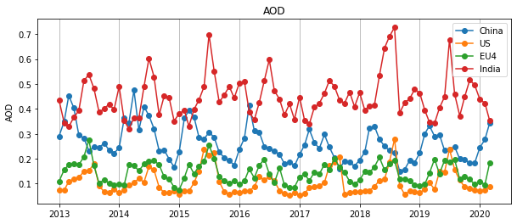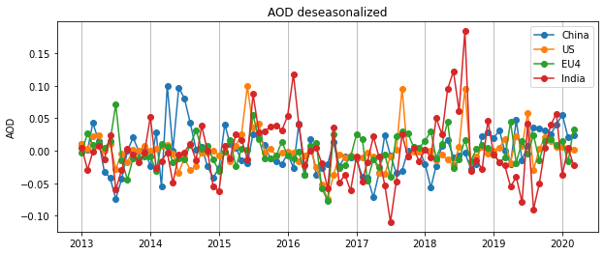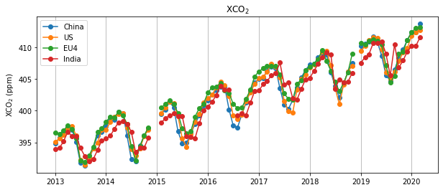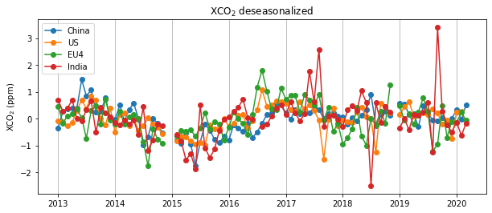
(a)
(b)
(c)
(d)
(e)
(f)
Figure 5. Left panels (a-c): the monthly series of NO₂, AOD and XCO₂ over China, US, EU4 (UK, France, Germany, and Italy), and India; Right panels (d-f): de-trended and de-seasonalized time series.

On the contrary, we do not see clearly impact of COVID-19 on AOD and XCO₂ for those regions. The lifetime of NO₂ in the atmosphere is about 52 minutes¹⁴, aerosols last days to weeks¹⁵, and CO₂ is over 100 years¹⁶. We expect some delays in AOD and XCO₂ if any impact of COVID-19 exists. However, China has controlled the epidemic within two months, we may not be able to see changes in AOD and XCO₂ due to their longer lifetime greater than two months. The extended monitoring beyond the pandemic can validate these theories. Moreover, aerosol formation, transformation, and removal processes are highly complex^{17,18}, which make aerosol atmospheric burdens highly non-linear with the emissions of their precursor gases, like NO₂.
Uncertainty
CO₂ emission show a linear relationship with the energy consumption in most countries, and thus the uncertainty of using proxy data to assess the growth rate is well within the uncertainty of the statistical data itself. Previous estimates quantified the uncertainty of ±20% for carbon emission in emerging economies and ±5% for global average¹⁵, however, the projections of emission growth from one year to the next based on GDP or monthly energy statistics show larger uncertainty, for example, the initial emission estimates of China based on Monthly statistics result in a 4.8% growth in 2018 with uncertainty range expand from 1.3% to 8.3% by considering the uncertainty from both the energy statistics and the emission factors, here we conservatively considered the same uncertainty range from previous emission estimates that based on the monthly statistics and Monte Carlo simulation of 10000 trials to estimate the 68% confidence interval (i.e., one sigma range) for China (See Methods). The consistence of the results shows robust about the calculation of one year’s growth rate based one the monthly statistics (Figure 6).
For satellite observations, the overall uncertainty of tropospheric NO2 columns monthly mean is 10%¹⁹. The uncertainty of AOD is approximately 0.03+0.20τ_{M}, where τ_{M} is AOD at 550 nm²⁰. In other words, the uncertainties in percentage in low AOD regions (US and EU4) is higher in high AOD regions (China and India). The standard deviations of XCO₂ monthly mean over land are about 0.5-1.5 ppm²¹. Here we conservatively considered uncertainty of monthly XCO₂ as 1.5 ppm. To estimate the uncertainty of changes of 2020 compared to 2019 from January to March, we input above uncertainties of monthly means and run Monte Carlo simulations of 10000 trials to calculate the 68% confidence intervals (i.e., one sigma range) which are shown in Table 1.
Discussion
It is still unclear how much the global CO2 emission will change at the end of this year, and how fast the economic and industry will resume back to normal. With the policy support, economy will be stimulated since the pandemic fade. IMF predicts the global annual economic output will decrease sharply by -3.0% in 2020 which is worse than the financial crisis in 2008 ²², based on the assumption that the COVID-19 will fade globally in the second half of this year. The emission decline is estimated to be less than 5%, and the future trend will be affected by the pandemic in Europe and US. Current statistics is still not capable to comprehensively capture the dynamics of the CO2 emission under the COVID19 pandemic and further monitoring, observation and data collecting are urgent needed.
-------------------------------------------------------------------------------------------------
Methodology
- CO2 emission data in 2019.
The CO2 emissions and sectoral structure in 2017 for countries and regions are extracted from International Energy Administration (IEA)²³, and the emissions are scaled to 2018 and 2019 based on the growth rates from EDGAR⁹ and Global Carbon Budget 2019²⁴ respectively. For countries with no current estimates of emission growth rates in 2019 such as Russia, Japan and Brazil, we assume their growth rates of emissions were 0.5% based on the emission growth rates of rest of world from Global Carbon Budget 2019²⁴.
Given the large uncertainty of CO₂ emission in China^{25,26}, we calculated the CO₂ emissions in China based on the methodology developed²⁷ previously:
Emissions= $\sum{\sum{\sum{{(Energy consumption data}_{i,j,k}×{Emission factors}_{i,j,k})}}}$ (1)
$i,j,k$ reflect the regions, sectors and fuel types respectively. In our calculation,$i$ covers XX countries that representing 70% of global total emissions. $j$ covers four sectors that are power generation, industry, transportation and household consumption, $k$ covers three primary fossil fuel types which are coal, oil and natural gas. Emission factors can be further separated into the net heating values for each fuel “v”, the energy obtained per unit of fuel (TJ per t fuel), the carbon content “c” (t C TJ-1 fuel) and the oxidization rate “o”, which is the fraction (in %) of fuel oxidized during combustion and emitted to the atmosphere.
$$Emission=\sum{\sum{\sum{{(Energy consumption data}_{i,j,k}×v_{i,j,k}×c_{i,j,k}×o_{i,j,k})}}}$$
We assume the emission factors and the structure remain unchanged for each country in 2020 when comparing with 2019. Thus, the rate of change of the emission is calculated based on the change of the energy consumption in 2020(for first quarter) when comparing the 2019.
CO₂ emission show liner relationship with the energy consumption in most countries, and thus the uncertainty of using proxy data to assess the growth rate is well within the uncertainty of the statistical data itself. Previous estimates quantified the uncertainty of ±20% for carbon emission in emerging economics and ±5% for global average¹⁵. For uncertainty of using monthly, weekly or hourly proxy statistics of activity data(power generation, industrial output etc.) to calculated the growth rate emission for whole year, we adopted the uncertainty range based on the estimates of annual emission by monthly statistics in China²⁸. This is a conservatively estimation given that the data and statistics in China is considered to be one of the largest in the world. We calculated the 68% prediction interval of these linear regression models and used them to reflect the one-sigma uncertainty involved when using the monthly data to represent the whole year’s variation (figure 6). The squared correlation coefficients are within the range of 0.88 (e.g., coal production) and 0.98 (e.g., energy import and export data), which represent that only using the monthly data can explain 88% to 98% of the whole year’s variation²⁸, while the remaining variation not covered yet reflect the uncertainty caused by the frequent revisions of China’s statistical data after they are first published. Such conservative calculation result in +-73% of the uncertainty range (one sigma).
Figure 6. Correlation between the growth rates of monthly statistics with those from the whole year between 1990 and 2018. The x value is certain year’s growth rate that calculated based on monthly statistics of the year, the y value is the growth rate for whole year. The consistence of the results shows robust about the calculation of one year’s growth rate based one the monthly statistics.

- CO₂ emission change rates in 2020 when comparing with 2019.
Based on the assumption of sectoral carbon intensity and energy structure remain unchanged from 2017, we scale the sectoral CO₂ emissions to 2020 by using proxy data for sectors:
For power generation:
For China and Japan, only monthly electricity generation statistics are available on the National Bureau of Statistics in China (http://www.stats.gov.cn/tjsj/). However the latest observation in Japan was in February 2020. We collect the daily electricity generation data from four electricity company (Hokkaido Electric Power Co., Inc., Tohoku Electric Power Network Co., Inc., TEPCO Power Grid, Incorporated, Chubu Electric Power Grid Co.,Inc., and Hokuriku Electric Power Transmission & Distribution Company) in Japan, which accounts for around 50% of the total generation, and calculate the monthly growth rate in March to scale the total electricity generation data to March in Japan. For US, daily total electricity generation data of the Lower 48 states are collected from Energy Information Administration’s (EIA) Hourly Electric Grid Monitor (https://www.eia.gov/beta/electricity/gridmonitor/). For EU countries and UK, electricity generation data every 15 minutes by production types are collected from ENTSO-E Transparent platform (https://transparency.entsoe.eu/dashboard/show). Due to the poor data quality or missing data, Croatia, Cyprus, Ireland, Luxembourg and Malta are excluded in the calculation. The hourly data of the other 23 EU countries (including Austria, Belgium, Bulgaria, Czech Republic, Denmark, Estonia, Finland, France, Germany, Greece, Hungary, Italy, Latvia, Lithuania, Netherlands, Poland, Portugal, Romania, Slovakia, Slovenia, Spain, Sweden) and United Kingdom are aggregated into daily total electricity generation data. For India, daily total electricity generation data are updated by Power System Operation Corporation Limited (https://posoco.in/reports/daily-reports/). For Russia, daily electricity generation data are collected from United Power System of Russia. For Brazil, daily electricity generation data are downloaded from the Operator of the National Electricity System (http://www.ons.org.br/Paginas/ ). All the daily electricity generation data are further aggregated into monthly data to calculate the monthly growth rates. For the monthly emissions in 2019, we use the monthly electricity generation for countries to allocate the emissions in power sector for each month. Then we calculate the monthly emissions in 2020 based on the monthly growth rates compared to the same periods in 2019.

For Transportation:
The mobility trends from the Google COVID-19 Community Mobility Reports (https://www.google.com/covid19/mobility/) are mainly used in this study. The mobility changes are calculated based on the visits and visit duration in six places categories, including grocery & pharmacy, parks, transit stations, retail & recreation, workplace, and residential. The daily mobility changes are compared to the median value during the first five weeks in 2020 for the corresponding day of the week as the baseline value. Except for residential, we consider that the mobility change of visits in the other five places representing the total mobility, so we calculate the daily average mobility change of five of the place categories to represent as the changes of the total traffic volume in these countries, based on the assumption the mobility in the same period in 2019 and January in 2020 is at the same level of the baseline value. The average mobility of EU countries except for Cyprus (lack of data) is used to estimate the emission growth in EU countries.
In China, we use the change of the Baidu Migration Scale Index to characteristic the change of transport sector, due to the lack of data in Google Community Mobility Reports in China. This index is aggregated from migration flows within the nation based on the positioning requests on Baidu Map services. The migration scale index is reported since Jan. 12th in 2019 and Jan. 1st in 2020, 9 days before the start of the Spring Festival travel rush every year. To fill the data gap between Jan. 1st 2019 to Jan. 11th, 2019, we use the average value of migration index between Jan. 12th, 2019 and Jan. 20th, 2019. Then we aggregate the daily index into monthly total and calculate the monthly changes in 2020 compared to 2019.
In Russia, because the lack of data and the earliest lockdown policy implementing on Mar. 30th in Moscow, we assume that the transport emissions remain unchanged in the first quarter in 2020.

For Industry:
For China, the industrial sector is divided into four industries including steel industry, cement industry, chemical industry, and other industry. For the steel industry, we collect the global monthly crude steel production data from World Steel Association (https://www.worldsteel.org/ ). For cement industry, China’s monthly cement production data are available on the National Bureau of Statistics. We estimate the growth rate of chemical production in China chemical industry by calculating the average cumulative growth rates of sulfuric acid, caustic soda, soda ash, ethylene, chemical fertilizer, chemical pesticide, primary plastic and synthetic rubber. For other industry, we estimate the change in China other industry by calculating the average cumulative growth rates of 26 industrial products (crude iron ore, phosphate ore, salt, feed, refined edible vegetable oil, fresh and frozen meat, milk products, liquor, soft drinks, wine, beer, tobaccos, yarn, cloth, silk and woven fabric, machine-made paper and paperboards, newsprint, plain glass, ten kinds of nonferrous metals, refined copper, lead, zinc, electrolyzed aluminum, industrial boilers, metal smelting equipment, and cement equipment). Based on the emission distribution of these four industries in industrial sector in China, we finally get the annual growth rate of industrial sector in China.
For US and Russia, we use the cumulative Industrial Production Index (IPI) from Federal Reserve Board (https://www.federalreserve.gov) and Federal State Statistics Service (https://eng.gks.ru) respectively, to estimate the growth rates of the emissions in these countries.
For India, the industrial sector is divided into steel industry, cement industry, and other industry. Emissions from steel industry and cement industry account for 60% of the total emissions in industrial sector of India. The steel production in India is extracted from World Steel Association. India’s monthly cement production data could be found from the Office of the Economic Advisor, but the last observation was on February. We assume that the cement production in India has dropped 40% in March. For other industry, we assume the growth rate is the average of growth rates of steel production and cement production.
For EU27, UK, Japan and Brazil, we use the cumulative Industrial Production Index (IPI) to estimate the growth rates of emissions in these countries or regions. However, the last observation in EU27 and UK was in January 2020 and those in Japan, Russia and Brazil were in February 2020. To estimate the current growth in March 2020, for EU27 and UK, we assume that the monthly growth rate in February 2020 equals to that of the same month in 2019. The monthly growth rate in March 2020 in EU27 and UK together has fell 5%, based on the assumption of the average growth rate of industrial sector in China (-8.1%) and US (-2.2%) because of the implement of locking down policies later than China but earlier than US. For Japan and Brazil, as looser travel restriction in these countries, we assume the monthly growth rates in March were -3% compared to February.

For international aviation:
The International Council on Clean Transportation (ICCT)²⁹ published that CO2 emissions of commercial aviation from international passenger movements totaled 444 Mt in 2018 and implied annual compound growth rate of total emissions from commercial flights, 5.7%, during the past five years from 2013 to 2018¹. Sub-national CO2 emissions from international passenger operations based on the location of flights departing airports are provided by ICCT. It is known that total CO2 emissions from all commercial operations include passenger movement, belly freight, and dedicated freight. ICCT published that passenger transport accounted for 81% of total emissions in 2018, so we use this proportion to estimate the international aviation emissions from commercial flights in 2018. Due to the lack of emissions data after 2018, We use the compound growth rate of commercial aviation emissions, 5.7%, to estimate the international aviation emissions from commercial flights in 2019. Based on the assumption that the number of international commercial flights and the number of total commercial flights including domestic and international flights have the same distribution over time, we collect the number of sub-national commercial flights for each week in the first quarter in 2019 and the same week in 2020 from OAG to estimate international aviation emissions from commercial flights for each week during this period. Daily tracking statistics about commercial flights and total flights in 2020 are provided by Flightragar24, which are collected to estimate the international aviation emissions from total flights in the first quarter in 2020 according to the proportion of the number of total flights and commercial flights. Due to the lack of such tracking statistics in 2019, we assume that the number of commercial flights and the number of total flights have the same change rate from 2019 to 2020 to estimate the international aviation emissions from total flights in the first quarter in 2019.
For global shipping
The Third IMO GHG Study published global shipping CO₂ emissions from 2007-2012 ³⁰. And we collected global shipping CO₂ emissions during the period of 2013-2015 from ICCT report ³¹. In addition, IEA released international shipping CO₂ emissions from 2000 to 2018 (https://www.iea.org/reports/tracking-transport-2019/international-shipping).
International shipping CO₂ emissions released by IEA were on average 23% lower than those published by IMO. We used this ratio to modify international shipping CO2 emissions from IEA. According to the Third IMO GHG Study, CO₂ emissions from international shipping accounts for 87% of global shipping emissions, domestic and fishing accounts for 9% and 4%, respectively. We estimated global CO2 shipping emissions from 2016-2018 with the modified IEA’s international emissions and the ratio between international shipping and global shipping emissions. And we extrapolated emissions from 2007-2018 to estimate emissions in 2019. We obtained emissions for the first quarter of 2019 based on the assumption that monthly variation is flat in shipping CO₂ emissions. In addition, we assume that the change in shipping emissions is linearly related to the change in ship’s volume. We collected the change in container ships (https://www.straitstimes.com/business/economy/coronavirus-global-container-shipments-set-to-fall-30-in-next-few-months), bulk carriers ship (http://www.eworldship.com/html/2020/bulk_market_0408/158450.html), Oil Tankers (http://www.eworldship.com/html/2020/ship_market_observation_0415/158673.html) and Other 19 ship class (http://www.msivt.com/news/archive/2020).
- Satellite observation and data sources:
We obtained monthly NO₂ data from the Ozone Monitoring Instrument (OMI) provided by Tropospheric Emission Monitoring Internet Service (TEMIS), which has with a spatial resolution of 0.125° x 0.125° and a temporal coverage from January 2013 to March 2020. For AOD, we chose daily Level 2 MOD 04 data from MODIS (Levy et al., 2015) and then calculated the monthly averaged AOD f from January 2013 to March 2020. Only “good” and “very good” data (in AOD_550_Dark_Target_Deep_Blue_Combined_QA_Flag 2 and 3) were kept in the calculation. At last, we calculated the monthly XCO2 data with a resolution of 2.5° x 2.5° from the Greenhouse Gases Observing Satellite "IBUKI" (GOSAT). Because of the delay in the data processing at National Institute for Environmental Studies (NIES), we used a bias-uncorrected version V02.81 for the period of January 2013 to March 2020. With the consideration of the focus on an abnormal event due to COVID-19, the bias-uncorrected data is proper for this study.
All of the monthly averaged data were regridded to 1° x 1°. We focused on four regions, China, USA, EU4 (UK, France, Germany, and Italy), and Indian, and then calculated the country level monthly averaged NO₂, AOD, and XCO₂ values. In order to highlight the historical abnormal events, we removed the inter-annual and seasonal variabilities from the monthly averaged country level data. Detrend and deseasonalization can largely reduce the impact of policy relevant changes and accentuate the anomalies in the time series.

Data Availability Statement
All data generated or analyzed during this study are included in this article (and its Data descriptor paper and supplementary information files).

Code Availability Statement
The code generated during and/or analyzed during the current study are available from the corresponding author on reasonable request.

Declaration
Authors declare no competing interests.

Acknowledgements
Authors acknowledge Paul O. Wennberg for insightful comments to improving this paper.

References:
1 Myllyvirta, L. Coronavirus temporarily reduced China’s CO2 emissions by a quarter. (2020).
2 Evans, S. Analysis: Coronavirus set to cause largest ever annual fall in CO2 emissions. (2020).
3 McKibbin, W. J. & Fernando, R. The global macroeconomic impacts of COVID-19: Seven scenarios. (2020).
4 Economics, O. World Economic Prospects Monthly.(4/2020). Economic Outlook 44 (2020).
5 Gopinath, G. The Great Lockdown: Worst Economic Downturn Since the Great Depression. (2020).
6 Crippa, M. et al. High resolution temporal profiles in the Emissions Database for Global Atmospheric Research. Scientific Data 7, 121, doi:10.1038/s41597-020-0462-2 (2020).
7 International Energy Agency. CO2 Emissions from Fuel Combustion 2019. (2019).
8 BP. BP Statistical Review of World Energy 2018. (2018).
9 Janssens-Maenhout, G. et al. EDGAR v4. 3.2 Global Atlas of the three major Greenhouse Gas Emissions for the period 1970–2012. Earth System Science Data 11, 959-1002 (2019).
10 Le Quéré, C. et al. Global carbon budget 2018. Earth System Science Data 10, 2141-2194 (2018).
11 Olivier, J. G., Schure, K. & Peters, J. Trends in global CO2 and total greenhouse gas emissions. PBL Netherlands Environmental Assessment Agency 5 (2017).
12 Shah, V. et al. Effect of changing NOx lifetime on the seasonality and long-term trends of satellite-observed tropospheric NO2 columns over China. Atmos. Chem. Phys. 20, 1483-1495, doi:10.5194/acp-20-1483-2020 (2020).
13 Zheng, B. et al. Trends in China's anthropogenic emissions since 2010 as the consequence of clean air actions. Atmos. Chem. Phys. 18, 14095-14111, doi:10.5194/acp-18-14095-2018 (2018).
14 Spicer, C. W., Kenny, D. V., Ward, G. F. & Billick, I. H. Transformations, lifetimes, and sources of NO2, HONO, and HNO3 in indoor environments. Air & Waste 43, 1479-1485 (1993).
15 Myhre, G., Myhre, C., Samset, B. & Storelvmo, T. Aerosols and their relation to global climate and climate sensitivity. Nature Education Knowledge 4, 7 (2013).
16 Forster, P. et al. in Climate Change 2007. The Physical Science Basis (2007).
17 Zhang, R. et al. Formation of urban fine particulate matter. Chemical reviews 115, 3803-3855 (2015).
18 Zhang, F. et al. An unexpected catalyst dominates formation and radiative forcing of regional haze. Proceedings of the National Academy of Sciences 117, 3960-3966 (2020).
19 Boersma, K. F. et al. Improving algorithms and uncertainty estimates for satellite NO2 retrievals: results from the quality assurance for the essential climate variables (QA4ECV) project. Atmospheric Measurement Techniques 11, 6651-6678 (2018).
20 Sayer, A. M., Hsu, N., Bettenhausen, C. & Jeong, M. J. Validation and uncertainty estimates for MODIS Collection 6 “Deep Blue” aerosol data. Journal of Geophysical Research: Atmospheres 118, 7864-7872 (2013).
21 Watanabe, H. et al. Global mapping of greenhouse gases retrieved from GOSAT Level 2 products by using a kriging method. International Journal of Remote Sensing 36, 1509-1528 (2015).
22 Economics, O. World Economic Prospects Monthly.(2/2020). Economic Outlook 44, 1-33 (2020).
23 IEA. World Energy Balances 2019. (2019).
24 Friedlingstein, P. et al. Global carbon budget 2019. Earth System Science Data 11, 1783-1838 (2019).
25 Guan, D., Liu, Z., Geng, Y., Lindner, S. & Hubacek, K. The gigatonne gap in China’s carbon dioxide inventories. Nature Climate Change 2, 672-675 (2012).
26 Marland, G. China's uncertain CO 2 emissions. Nature Climate Change 2, 645-646 (2012).
27 Liu, Z. et al. Reduced carbon emission estimates from fossil fuel combustion and cement production in China. Nature 524, 335-338 (2015).
28 Liu, Z., Zheng, B. & Zhang, Q. New dynamics of energy use and CO2 emissions in China. arXiv preprint arXiv:1811.09475 (2018).
29 The International Council on Clean Transportation. CO2 emissions from commercial aviation. (2019).
30 Smith, T. W. P. et al. Third IMO Greenhouse Gas Study 2014. (2015).
31 Olmer, N., Comer, B., Roy, B., Mao, X. & Rutherford, D. Greenhouse gas emissions from global shipping, 2013-2015. (2017).

Supplementary Information
SI Table 1 Sectoral changes in 2020 by countries or regions.
Electricity | Countries/Regions | Jan | Feb | Mar | Jan-Mar
Electricity | China | / | / | -4.6% | -6.8%
Electricity | India | 2.7% | 10.4% | -8.7% | 1.0%
Electricity | US | -6.8% | -1.0% | -6.7% | -4.9%
Electricity | Europe (EU27 &UK) | -3.8% | 1.2% | -4.5% | -2.5%
Electricity | Japan | -1.0% | -4.3% | -1.2% | -3.7%
Electricity | Brazil | -3.9% | 2.2% | -1.3% | -1.1%
Electricity | Russia | -3.4% | 0.5% | -2.9% | -2.0%
Transport | Countries/Regions | Jan | Feb | Mar | Jan-Mar
Transport | China | 2.6% | -75.1% | -34.2% | -37.2%
Transport | India | 0.0% | 1.0% | -22.9% | -7.6%
Transport | US | 0.0% | 4.3% | -10.0% | -2.7%
Transport | Europe (EU27 &UK) | 0.0% | 3.1% | -22.8% | -7.3%
Transport | Japan | 0.0% | -1.2% | -5.3% | -2.0%
Transport | Brazil | 0.0% | -0.6% | -20.0% | -6.9%
Transport | Russia | 0.0% | 0.0% | 0.0% | 0.0%
Industry | Countries/Regions | Jan | Feb | Mar | Jan-Mar
Industry | China | / | / | -6.9% | -8.1%
Industry | India | -0.4% | 3.9% | -22.7% | -7.0%
Industry | US | -1.2% | 0.1% | -5.5% | -2.2%
Industry | Europe (EU27 &UK) | -1.6% | -1.6% | -6.4% | -3.2%
Industry | Japan | -2.4% | -5.7% | -17.4% | -8.9%
Industry | Brazil | -0.9% | -0.5% | -5.8% | -2.4%
Industry | Russia | 1.1% | 3.3% | 0.4% | 1.6%

SI Table 2. Monthly changes in power sector in the first quarter in 2020 by countries or regions.
Countries/Regions | Jan | Feb | Mar | Jan-Mar
China |  |  | -4.6% | -6.8%
India | 2.7% | 10.4% | -8.7% | 1.0%
United States | -6.8% | -1.0% | -6.7% | -4.9%
Europe (EU27 & UK) | -3.8% | 1.2% | -4.5% | -2.5%
Brazil | -3.9% | 2.2% | -1.3% | -1.1%
Japan | -1.0% | -4.3% | -1.2% | -3.7%
Russia | -3.4% | 0.5% | -2.9% | -2.0%
European Countries
Austria | -14.5% | 7.7% | -2.2% | -3.7%
Belgium | 1.4% | 8.2% | -3.6% | 1.8%
Bulgaria | -14.1% | -9.0% | -10.6% | -11.3%
Czech Republic | -5.7% | -5.4% | -5.3% | -5.5%
Denmark | 2.3% | 16.8% | -12.7% | 1.5%
Estonia | -62.4% | -48.3% | -43.7% | -53.3%
Finland | -10.1% | 0.3% | 2.9% | -2.6%
France | -2.0% | 1.7% | -4.6% | -1.7%
Germany | -8.6% | 0.3% | -8.2% | -5.7%
Greece | -15.9% | -5.1% | -9.0% | -10.7%
Hungary | -4.7% | 18.4% | 21.3% | 9.8%
Italy | -5.7% | -2.5% | -14.5% | -7.6%
Latvia | 5.1% | 27.7% | -1.6% | 8.6%
Lithuania | 4.2% | 33.1% | -0.3% | 11.5%
Netherlands | 67.1% | 6.9% | -15.1% | 13.8%
Poland | -7.2% | 1.3% | -5.6% | -4.0%
Portugal | 15.8% | 15.8% | 17.7% | 16.4%
Romania | -0.8% | -5.5% | -3.0% | -3.1%
Slovakia | -2.8% | 8.3% | -3.1% | 0.5%
Slovenia | 3.7% | -10.9% | 0.7% | -2.3%
Spain | -7.2% | -0.8% | 2.2% | -2.2%
Swede | 3.5% | 5.6% | 6.6% | 5.2%
United Kingdom | -8.9% | 0.0% | -0.9% | -3.6%

SI Table 3. Monthly mobility changes in 2020 by countries or regions.
Countries/Regions | Jan | Feb | Mar | Jan-Mar
China | 7.4% | -75.1% | -34.2% | -36.2%
India | - | 1.0% | -22.9% | -7.6%
United States | - | 4.3% | -10.0% | -2.7%
Europe (EU27 & UK) | - | 3.1% | -22.8% | -7.3%
Brazil | - | -0.6% | -20.0% | -6.9%
Japan | - | -1.2% | -5.3% | -2.0%
European Countries
Austria | - | 7.9% | -30.1% | -9.0%
Belgium | - | -1.3% | -25.8% | -9.0%
Bulgaria | - | 6.1% | -23.9% | -7.1%
Croatia | - | 4.8% | -24.3% | -7.5%
Czechia | - | 5.0% | -20.8% | -6.3%
Denmark | - | -0.3% | -10.7% | -3.7%
Estonia | - | 1.3% | -12.9% | -4.2%
Finland | - | 1.5% | -11.5% | -3.7%
France | - | 2.1% | -34.9% | -11.5%
Germany | - | 1.9% | -14.1% | -4.5%
Greece | - | 4.9% | -27.2% | -8.5%
Hungary | - | 7.9% | -16.0% | -4.1%
Ireland | - | -1.6% | -19.8% | -7.0%
Italy | - | 1.3% | -51.5% | -17.3%
Latvia | - | 1.7% | -8.7% | -2.7%
Lithuania | - | 2.5% | -15.1% | -4.7%
Luxembourg | - | -1.3% | -28.7% | -10.0%
Malta | - | 11.3% | -24.7% | -6.5%
Netherlands | - | -0.9% | -14.9% | -5.2%
Poland | - | 2.8% | -23.1% | -7.4%
Portugal | - | 6.5% | -31.8% | -9.8%
Romania | - | 4.2% | -23.5% | -7.3%
Slovakia | - | 6.1% | -27.1% | -8.2%
Slovenia | - | 4.3% | -30.5% | -9.7%
Spain | - | 5.7% | -40.8% | -13.0%
Sweden | - | 0.8% | -6.3% | -2.0%
United Kingdom | - | -2.1% | -17.0% | -6.1%

SI Table 4. Growth rates of industrial sector comparing to the same periods of last year in 2020.
Countries/Regions | Jan | Feb | Mar | Jan-Mar
China |  |  | -6.9% | -8.1%
India | -0.4% | 3.9% | -22.7% | -7.0%
US | -1.2% | 0.1% | -5.5% | -2.2%
Europe (EU27 & UK) | -1.6% | -1.6% | -6.4% | -3.2%
Japan | -2.4% | -5.7% | -17.4% | -8.9%
Brazil | -0.9% | -0.5% | -5.8% | -2.4%
Russia | 1.1% | 3.3% | 0.4% | 1.6%

